DBMS – PRACTISE 11_1

Problem: −Create a list of all tables whose first two characters in the name of the table is JO −The tables must be owned by the current Oracle User.

CREATE TABLE JOBS,JOB_GRADE,JOB_HISTORY

(

INT JOB_ID(10),

NAME VARCHAR(100),

);

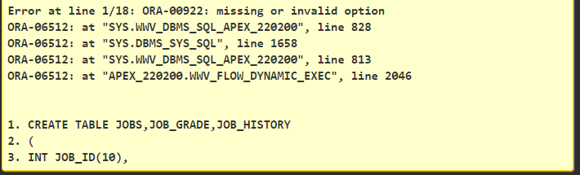

CREATE TABLE Emp

(

first_name VARCHAR(100),

last_name VARCHAR(100));

DESC Emp;

INSERT INTO Emp(first_name,last_name) VALUES ('vinay ','kumar');

INSERT INTO Emp(first_name,last_name) VALUES ('david','raju');

INSERT INTO Emp(first_name,last_name) VALUES ('samuel','rufus');

INSERT INTO Emp(first_name,last_name) VALUES ('agasteen','raju');

INSERT INTO Emp(first_name,last_name) VALUES ('salmon','raj');

SELECT first_name||' '||last_name

FROM Emp;

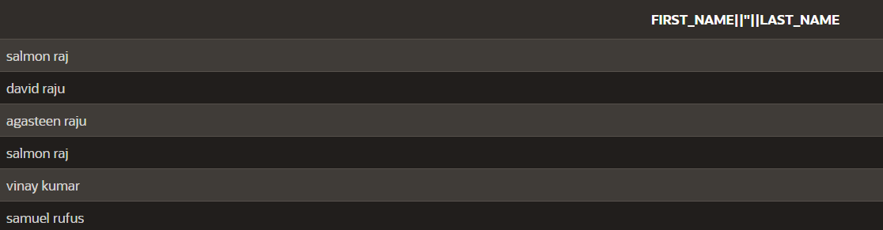

SELECT first_name ||' '||last_name AS "employee_name",Email

FROM Emp;

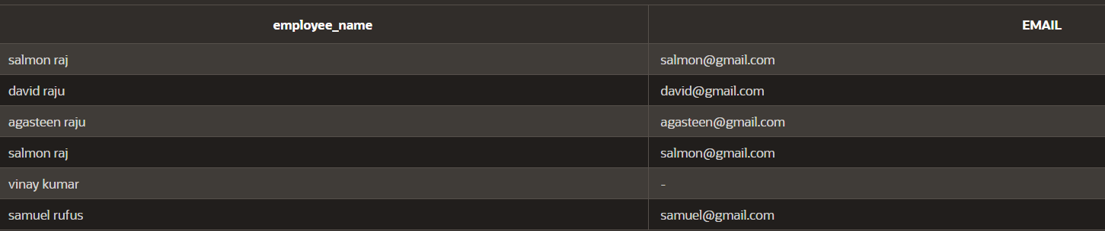

SELECT

MIN(last_name) AS smallest_last_name,

MAX(last_name) AS highest_last_name

FROM

employees;



UPDATE Emp

SET salary=700

WHERE first_name='vinay';

UPDATE Emp

SET salary=100

WHERE first_name='david';

UPDATE Emp

SET salary=1000

WHERE first_name='samuel';

UPDATE Emp

SET salary=2000

WHERE first_name='agasteen';

UPDATE Emp

SET salary=3000

WHERE first_name='salmon';

SELECT TO_CHAR(salary, '$9999.99') AS formatted_salary

FROM Emp

WHERE salary BETWEEN 700 AND 3000;

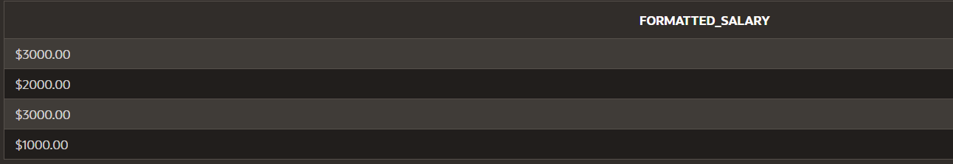

Problem: − Create a list of every employee and his related job title sorted by job_title

SELECT first_name||' '||last_name AS "Employee_name",job_title

FROM Employ

ORDER BY job_title;

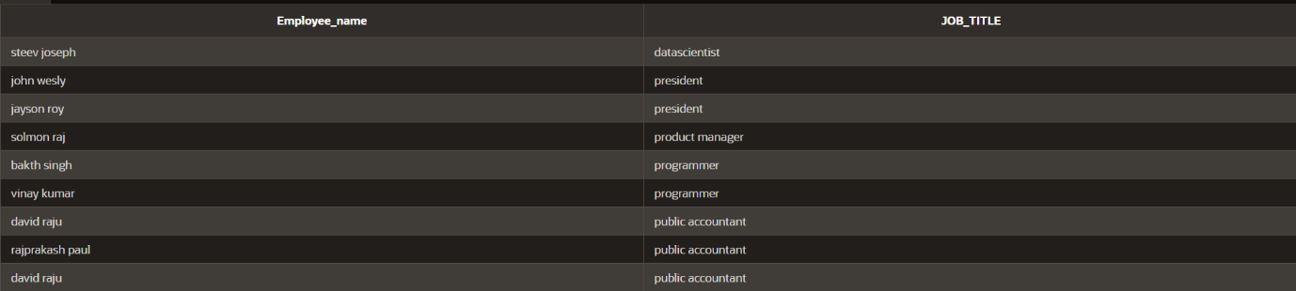

SELECT job_title,MIN(salary) || ' - ' || MAX(salary) AS salary_range,salary AS employee_salary

FROM Employ

GROUP BY job_title, salary

ORDER BY job_title, salary;

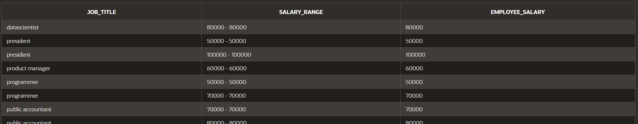

**CSA 0563 – DBMS**

**Cretaing a table by using CREATE**

CREATE TABLE STUDENT2

(

name VARCHAR(10),

std_id NUMBER(10),

age NUMBER(2),

course VARCHAR(10),

date_of_registration DATE

);

Inserting values into table by Using INSERT keyword

INSERT INTO STUDENT2 (name,std_id,age,course,date_of_registration)

VALUES ('ELIYAZAR',192311162,19,'DBMS',TO_DATE('10-07-2024','DD-MM-YYYY'));

INSERT INTO STUDENT2 (name,std_id,age,course,date_of_registration)

VALUES ('CHANIKYA',192311164,18,'DBMS',TO_DATE('10-06-2024','DD-MM-YYYY'));

INSERT INTO STUDENT2 (name,std_id,age,course,date_of_registration)

VALUES('CHANIKYA',192311164,18,'DBMS',TO_DATE('10-06-2024','DD-MM-YYYY'));

INSERT INTO STUDENT2 (name,std_id,age,course,date_of_registration)

VALUES('PRAKASH',192311165,19,'JAVA',TO_DATE('10-06-2024','DD-MM-YYYY'));

INSERT INTO STUDENT2 (name,std_id,age,course,date_of_registration)

VALUES('POLI',192311166,19,'JAVA',TO_DATE('11-07-2024','DD-MM-YYYY'));

INSERT INTO STUDENT2 (name,std_id,age,course,date_of_registration)

VALUES('VICKY',192311161,20,'DBMS',TO_DATE('10-07-2024','DD-MM-YYYY'));

**Displaying the tablevalues by using** **SELECT**

SELECT *

FROM STUDENT2;

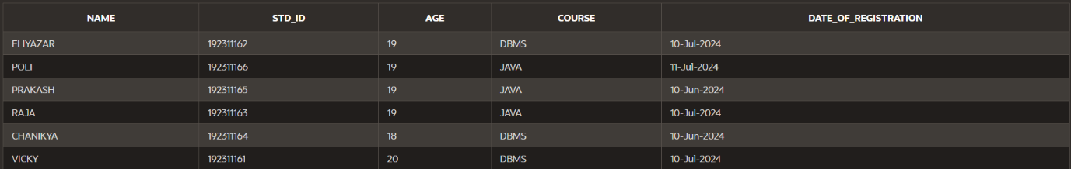

Appluying condition **WHERE**

SELECT name ,course,date_of_registration

FROM STUDENT2

WHERE std_id = 192311162;



Adding another column to a table by using ALTER and ADD

ALTER TABLE STUDENT2

ADD marks FLOAT;

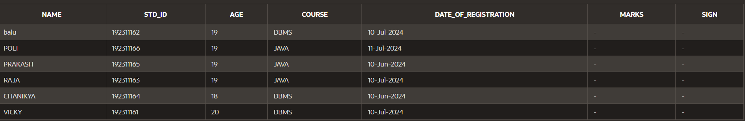

Deleting column name by using ALTER and DROP

ALTER TABLE STUDENT2

DROP (sign);

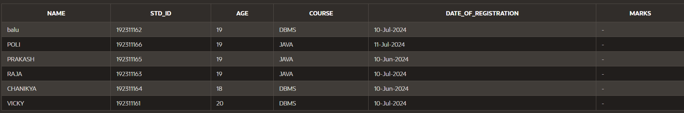

Updating the specified row in a table by using UPDATE,SET

UPDATE STUDENT2

SET name=’balu’

WHERE std_id=192311162;

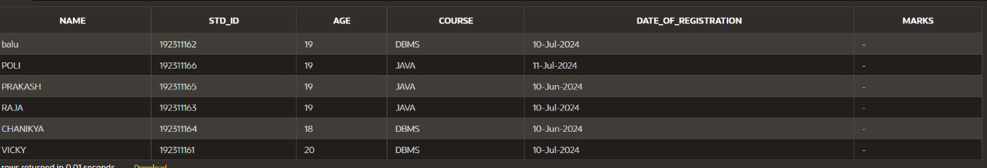

Deleting specifed row in a table by using DELETE keyword

DELETE FROM STUDENT2

WHERE name=’PRAKASH’

SELECT * FROM STUDENT2

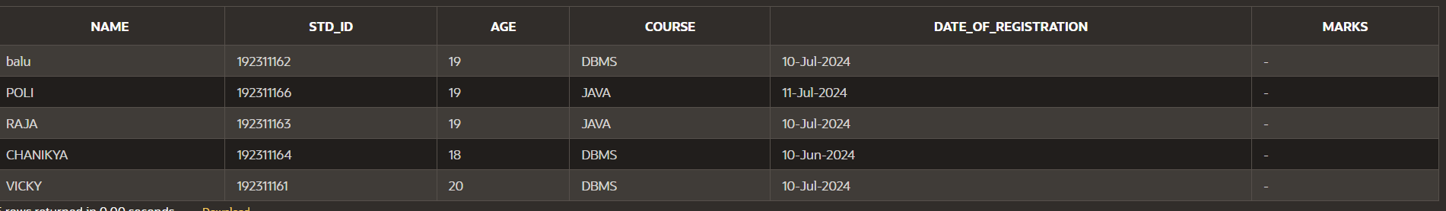

Deleting all the rows in a table by using TRUNCATE keyword

TRUNCATE TABLE STUDENT2;

SELECT * FROM STUDENT2;



Selecting only some columns in the table by using SELECT

SELECT emp_id,first_name,salary

FROM Employee;

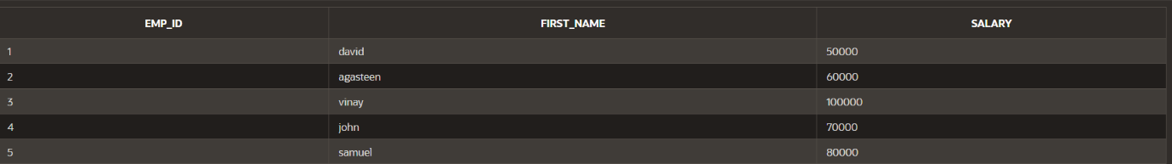

ARTHMETIC OPERATORS :

(+-*/)

SELECT emp_id, salary+3000

FROM Employee;

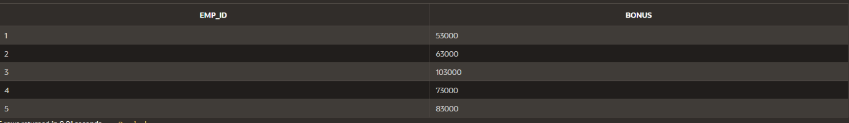

CONCATENATE two column name as one name by using AS :

SELECT first_name | | last_name AS Emp_name

FROM Employee;

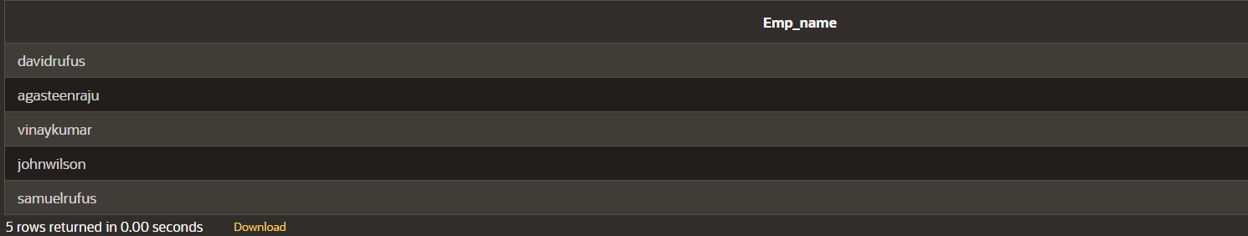

DESCRIBE Keyword

desc keyword

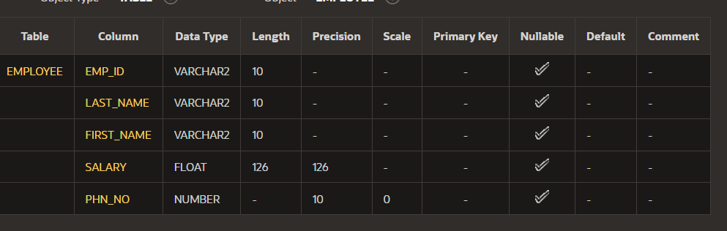

Using WHERE clause

SELECT first_name,last_name,salary

FROM Employee

WHERE salary > 50000.0;

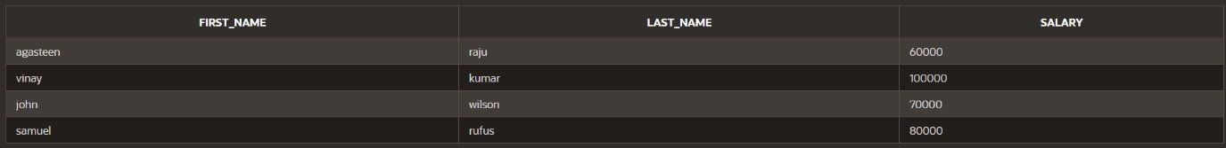

Using BETWEEN and AND operator

SELECT first_name,last_name ,salary

FROM Employee

WHERE salary BETWEEN 35000.0 AND 75000.0;

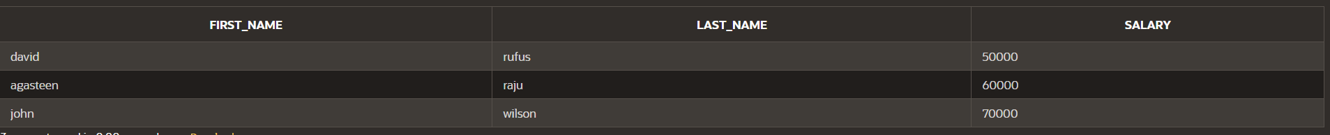

By using IN operator

SELECT first_name,last_name,salary

FROM Employee

WHERE emp_id IN (2,5);



By using NOT IN operator

SELECT first_name,last_name,salary

FROM Employee

WHERE emp_id NOT IN (2,5);



By using LIKE operator

SELECT first_name,last_name,salary

FROM Employee

WHERE last_name LIKE ‘r%’;

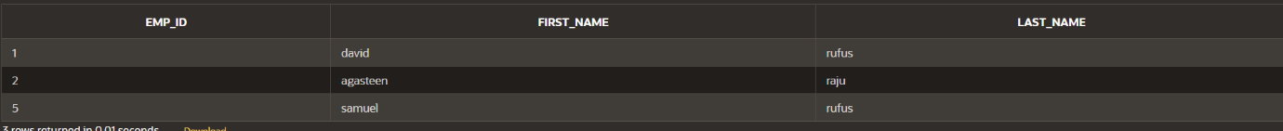

By using OR operator

SELECT emp_id,first_name

FROM Employee

WHERE emp_id=’1’ OR emp_id = ‘5’;



Arranging or ordering the tablein ASCENDING and DESCENDING ORDER by using ORDER BY

SELECT emp_id,first_name,last_name

FROM Employee

ORDER BY emp_id DESC;

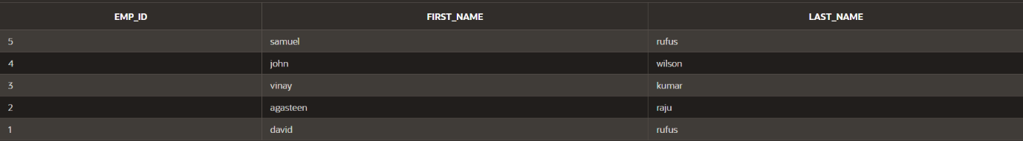

SELECT emp_id,first_name,last_name

FROM employee

ORDER BY last_name ;

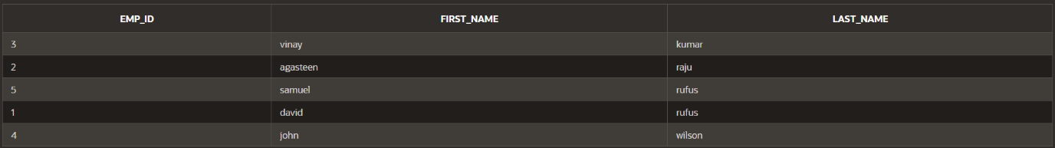

GROUP FUNCTIONS :

MAX :

SELECT MAX(salary)

FROM Employee;



MIN:

SELECT MIN(salary)

FROM Employee;



AVERAGE :

SELECT AVG(salary)

FROM Employee;



SUM :

SELECT SUM(salary)

FROM Employee;



More than one GROUP function :

SELECT MAX(Salary),MIN(Salary),MIN(emp_id)

FROM Employee

WHERE last_name='raju';



VARIANCE :

SELECT ROUND(VARIANCE(salary),2)

FROM Employee;



STANDARD DEVIATION :

SELECT ROUND(STDDEV(salary),2)

FROM Employee;



COUNT :

SELECT COUNT(emp_id)

FROM Employee;



COUNT(*)

SELECT COUNT(*)

FROM Employee

WHERE emp_id > 2;



DISTINCT

SELECT DISTINCT last_name

FROM Employee;

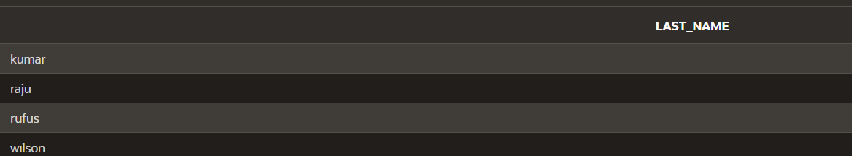

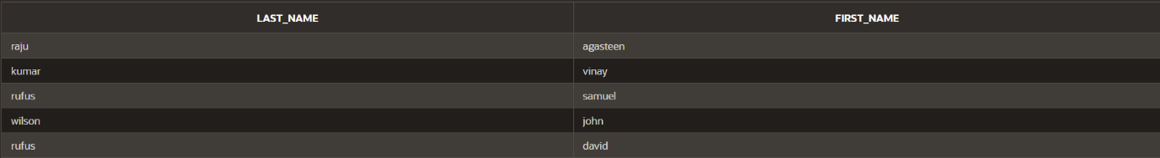

SELECT COUNT(DISTINCT salary)

FROM Employee;



SELECT AVG(NVL(salary,0))

FROM Employee;



**Section 9**

**DP 9.1:**

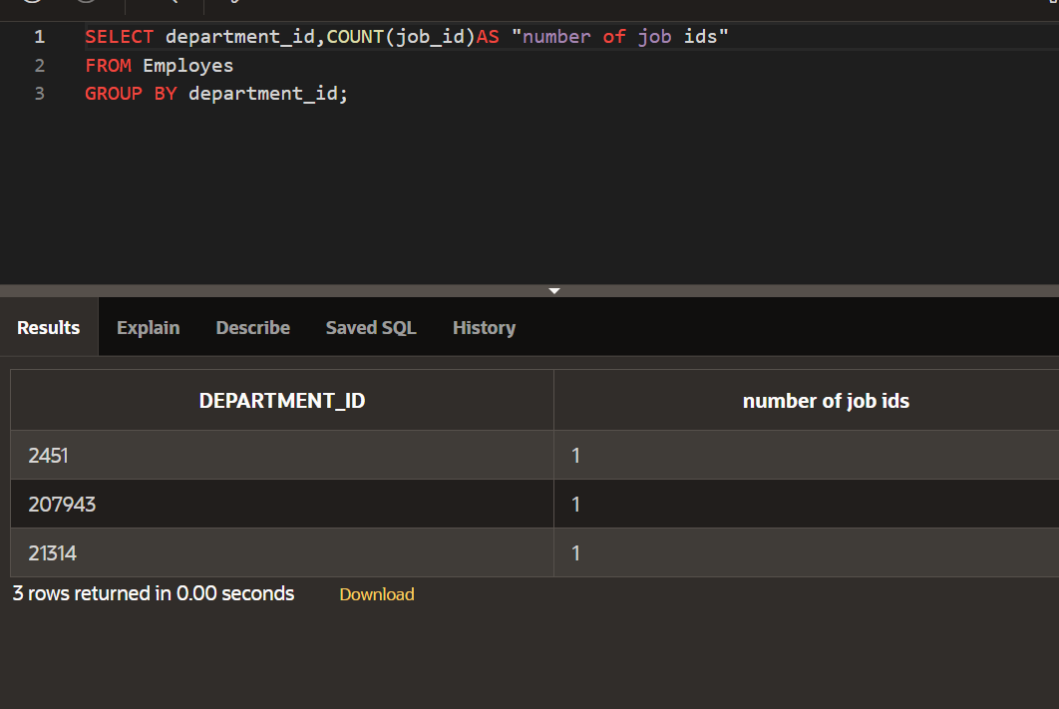

**DP 9.2:**

**DP 9.3:**

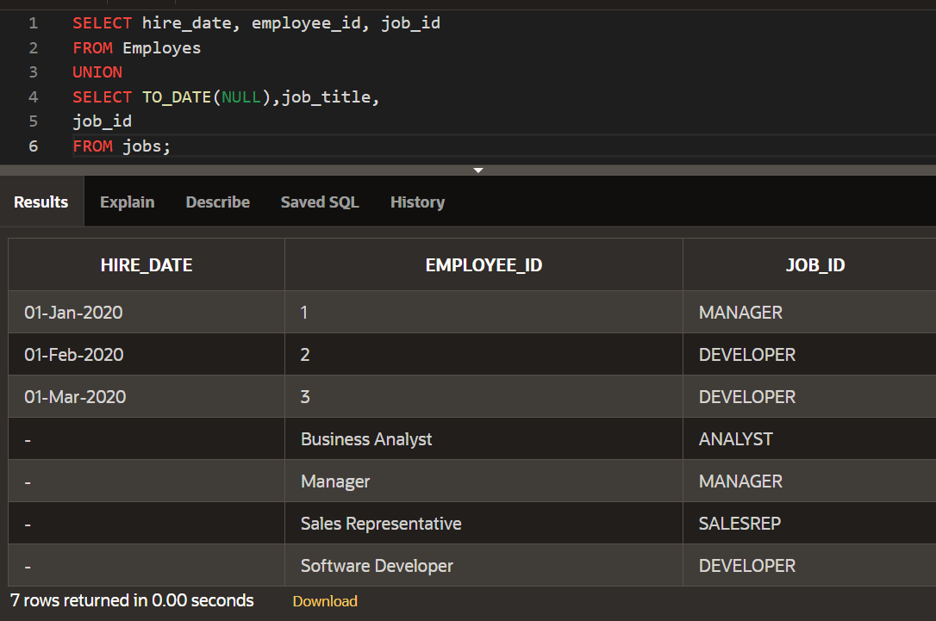

**SECTION 8**

**DP_8.1:**

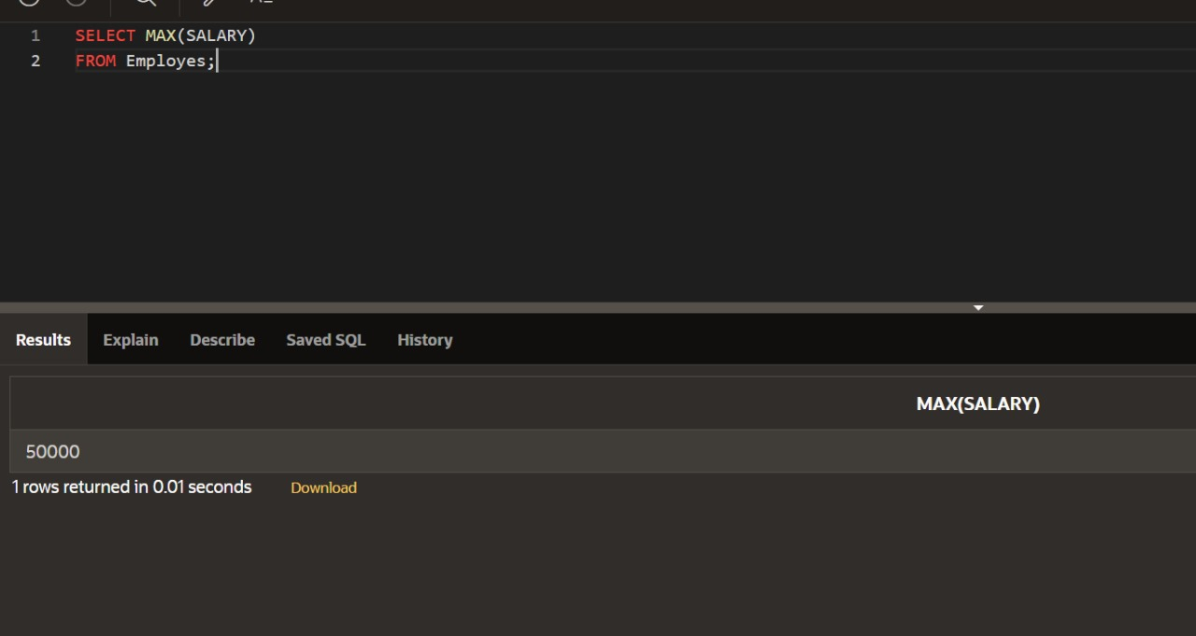

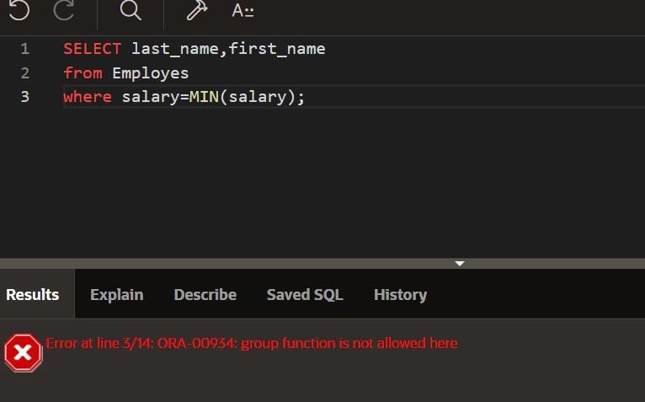

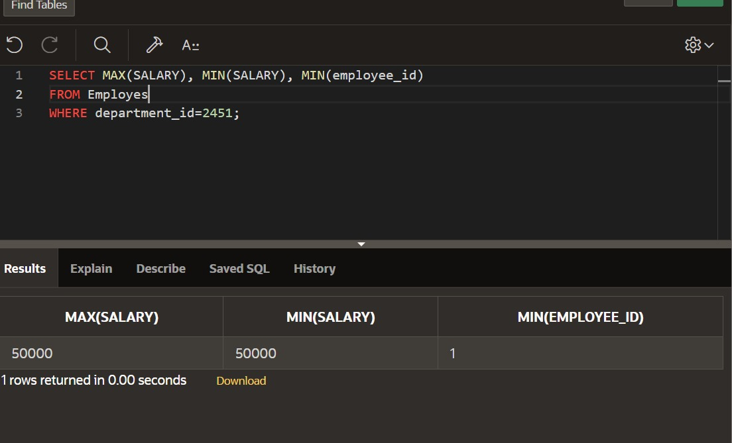

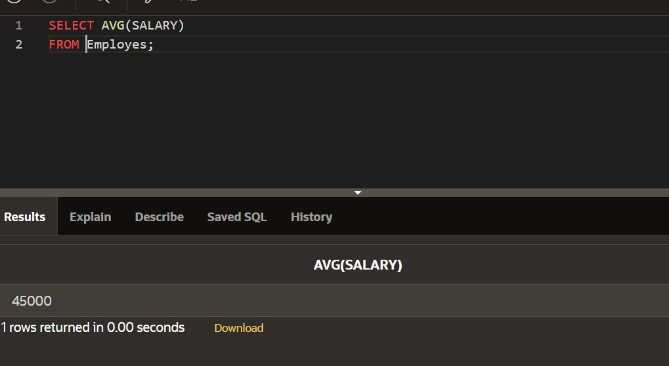

**DP_8.2:**

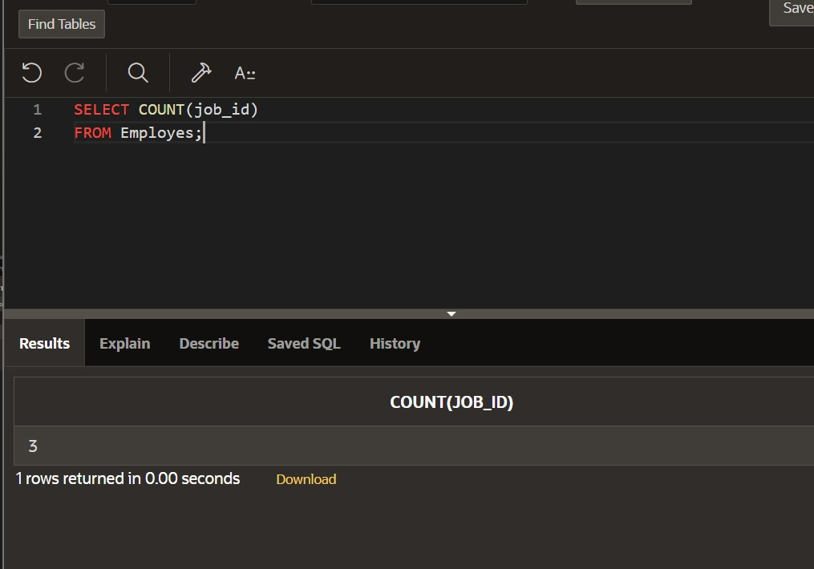 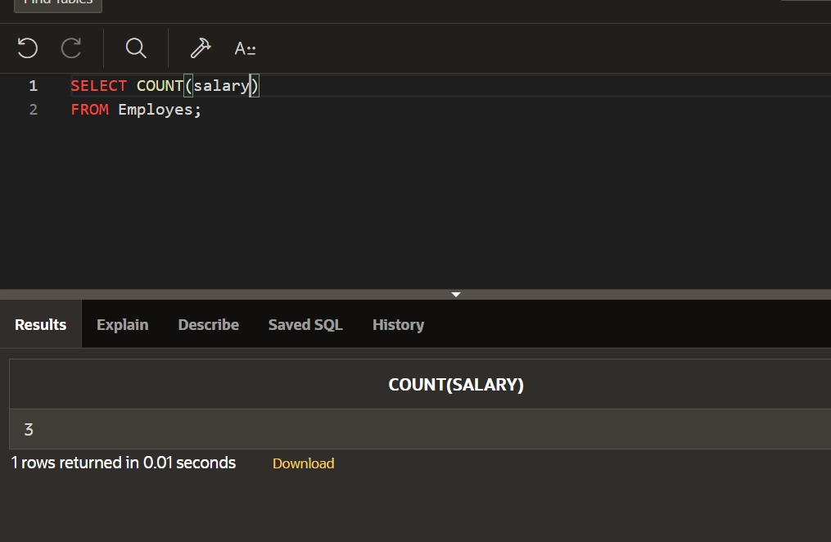 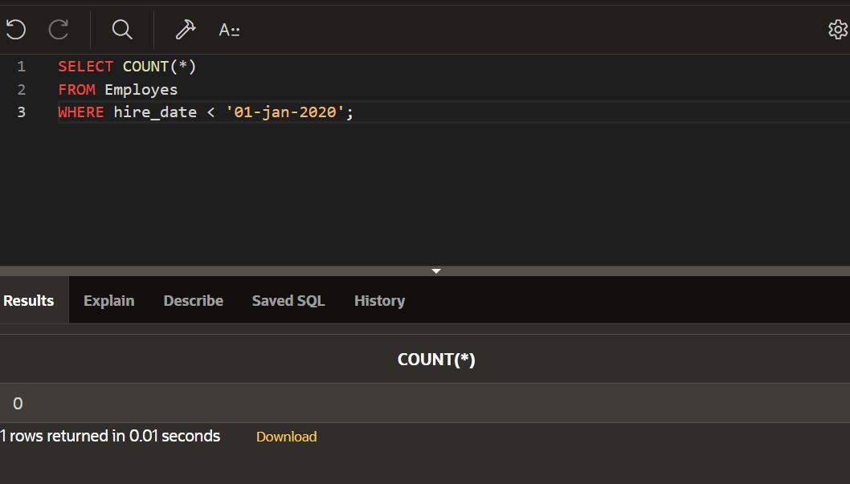 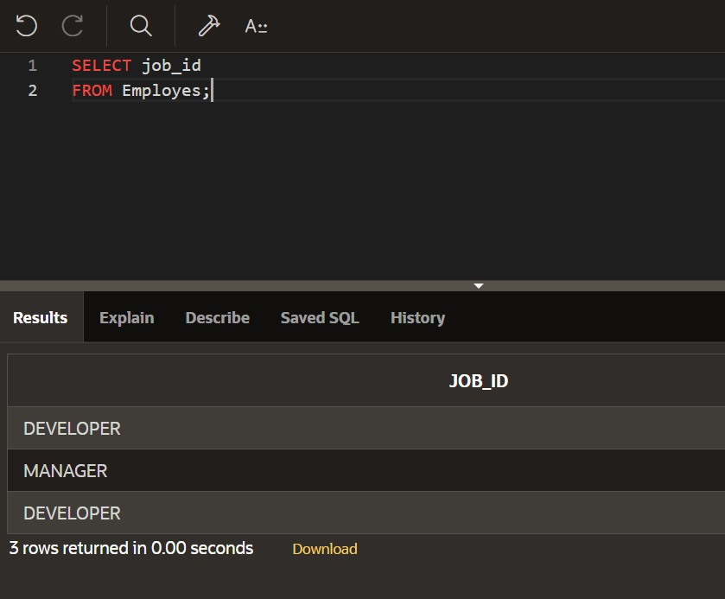 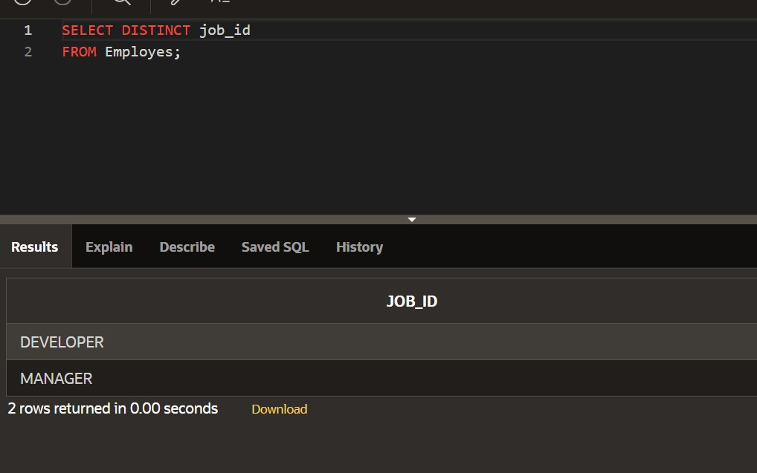 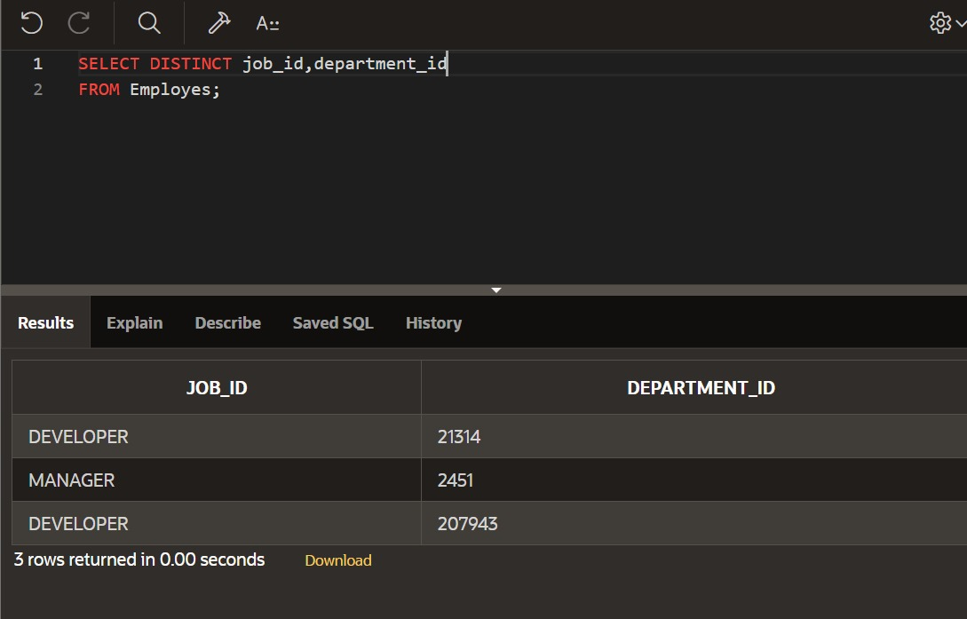 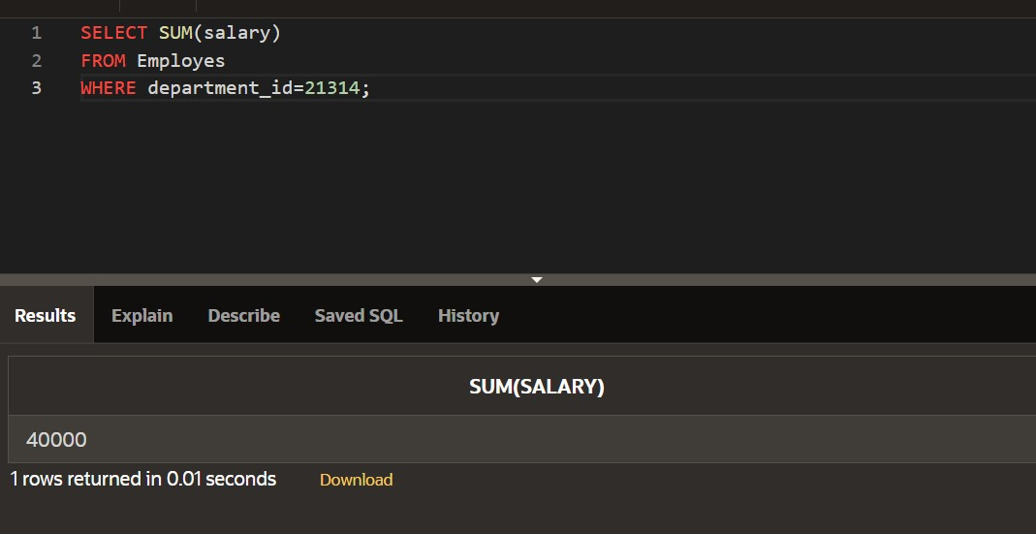 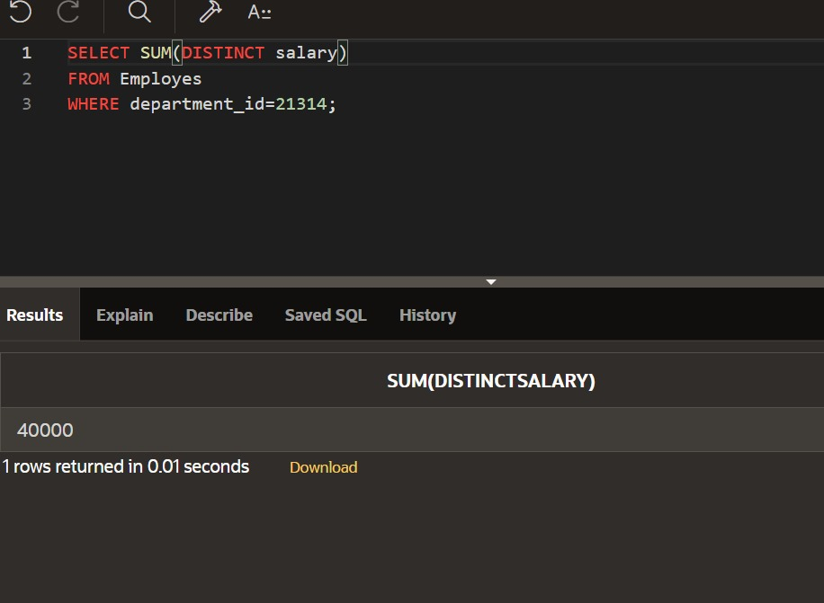 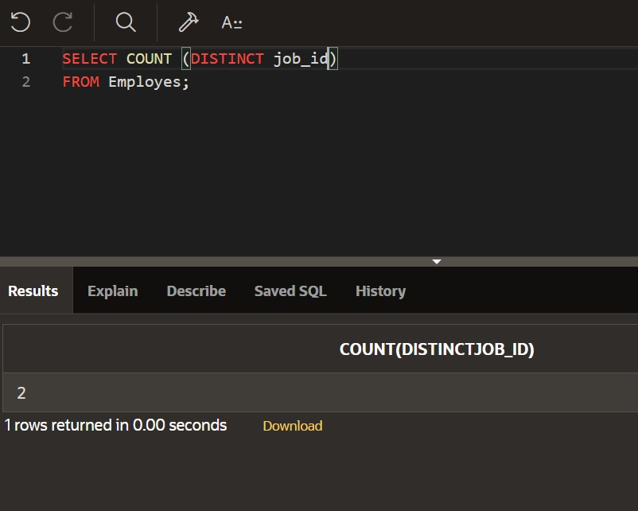 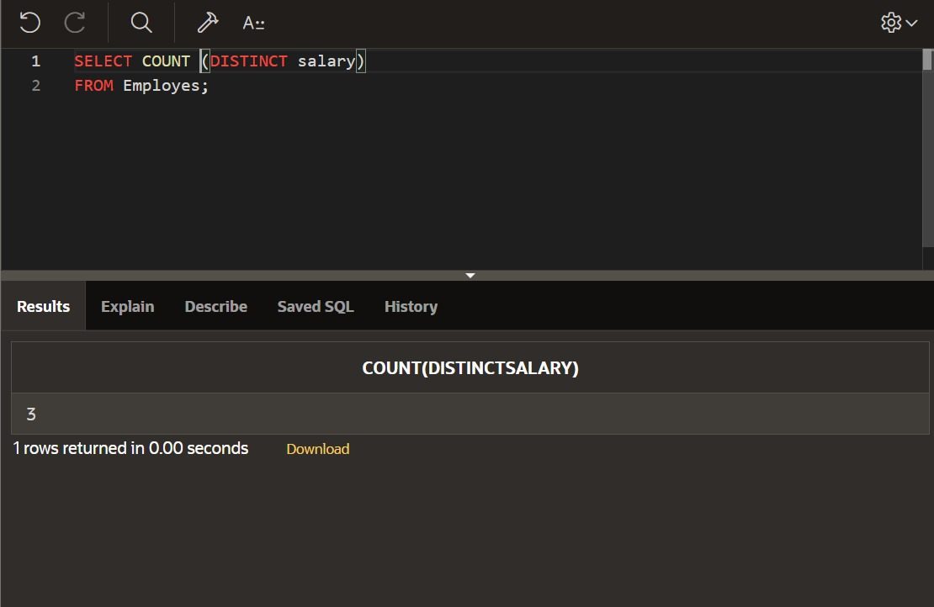 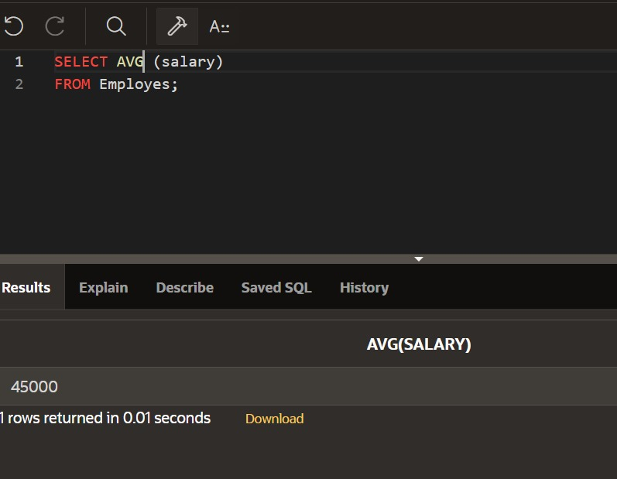

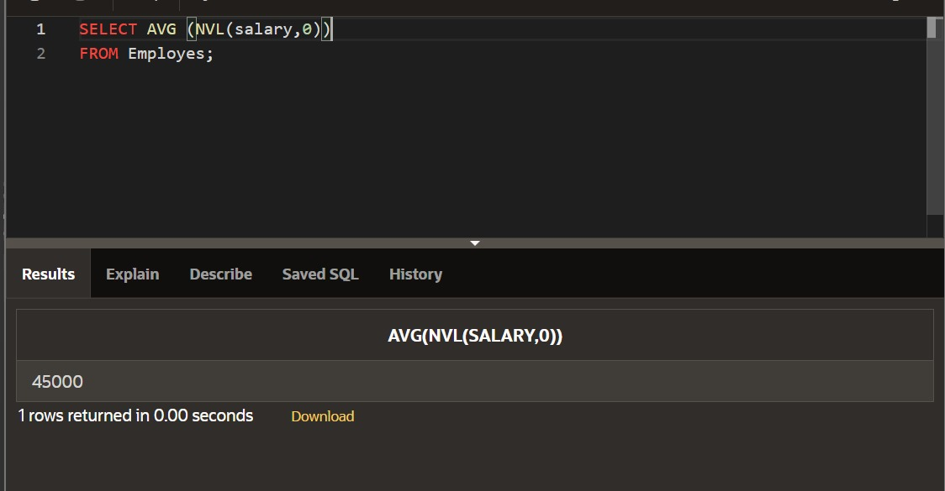

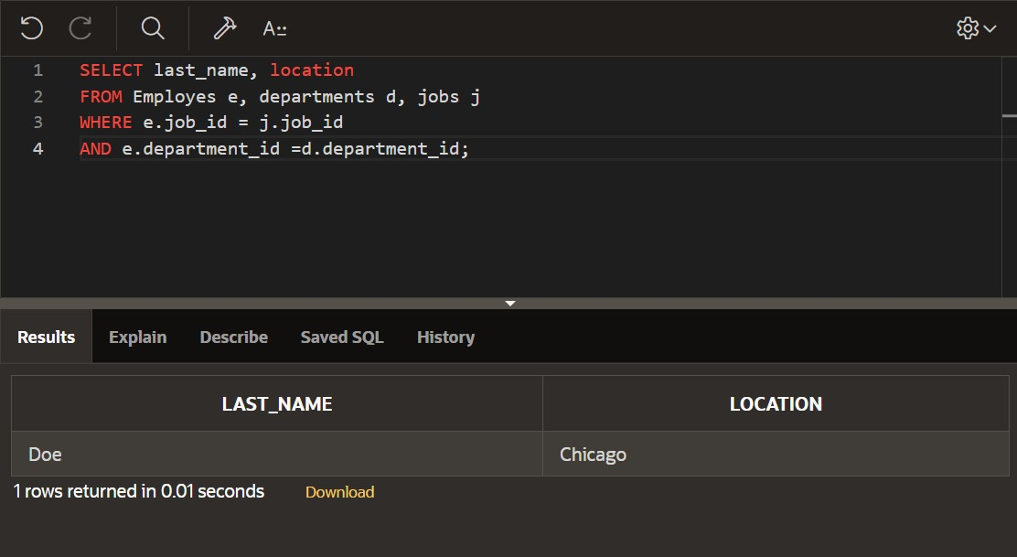

**DATABASE PROGRAMMING WITH SQL**

**7.1 Oracle Equijoin and Cartesian Product**

CREATE TABLE employ(

eno VARCHAR(14),

ename VARCHAR(14),

eadhress VARCHAR(15),

epno VARCHAR(15),

depno VARCHAR(14),

depname VARCHAR(14),

jobid VARCHAR(10),

salary VARCHAR(10),

create_date DATE DEFAULT SYSDATE);

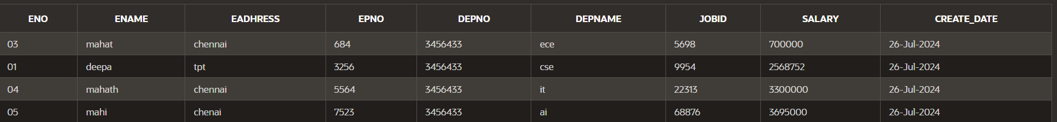

CREATE TABLE jobs (

job_id VARCHAR(10) PRIMARY KEY,

job_title VARCHAR(50) NOT NULL,

min_salary DECIMAL(8, 2),

max_salary DECIMAL(8, 2)

);



**PROPRIETARY JOINS:**

SELECT employ.ename, jobs.job_title

FROM employ,jobs

WHERE employ.jobid=jobs.job_id;

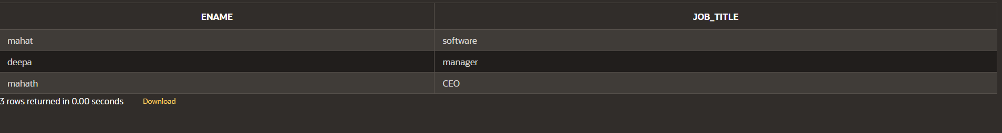

**EQUIJOIN:**

SELECT employ.ename, employ.jobid, jobs.job_title

FROM employ, jobs

WHERE employ.jobid = jobs.job_id;

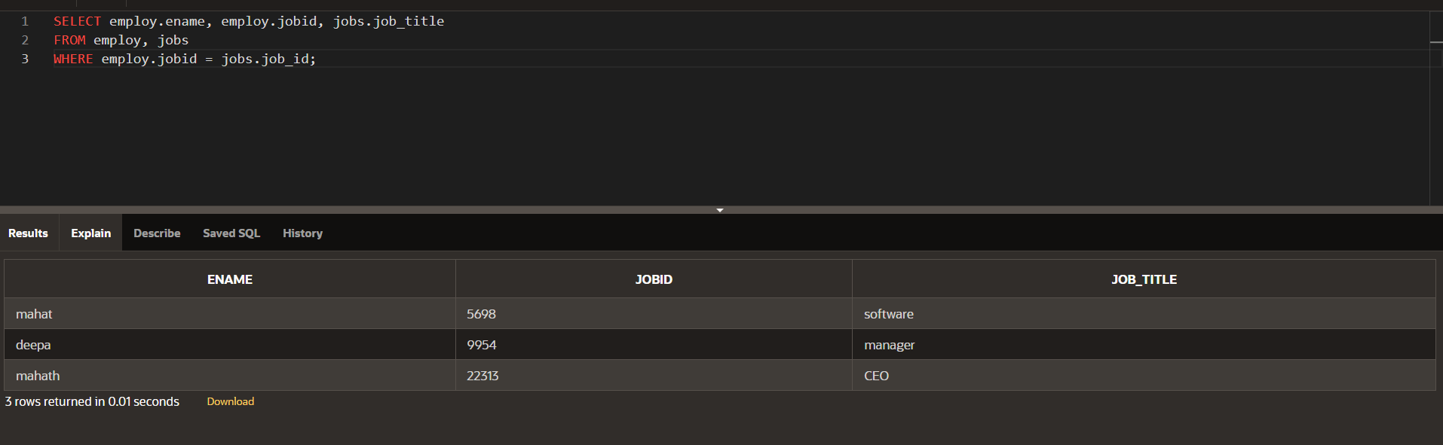

**ALIASES:**

SELECT ename, e.jobid, job_title

FROM employ e, jobs j

WHERE e.jobid = j.job_id

AND depno=3456433;

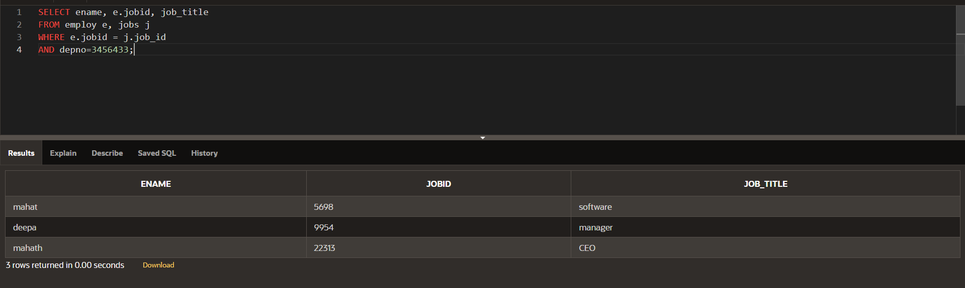

**CARTESIAN PRODUCT JOIN:**

SELECT employ.ename,jobs.job_title

FROM employ,jobs;

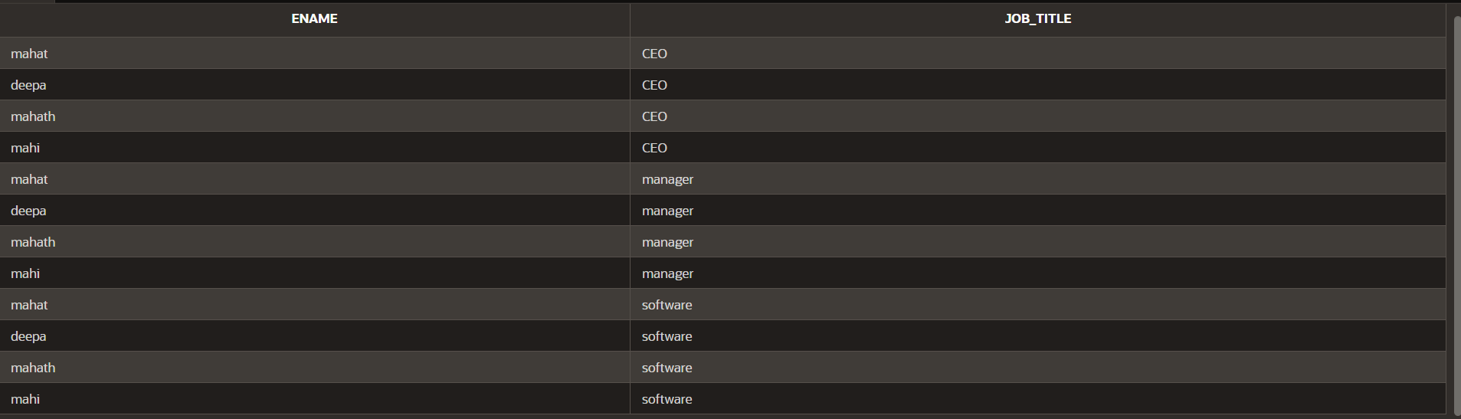

**JOIN:**

SELECT last_name, location

FROM Employes e, departments d, jobs j

WHERE e.job_id = j.job_id

AND e.department_id =d.department_id;



**DP_7.2:**

**Nonequijoin:**

SELECT ename,salary,grade,lowsal,

highsal

FROM employ,job_grade

WHERE (salary BETWEEN lowsal AND highsal);

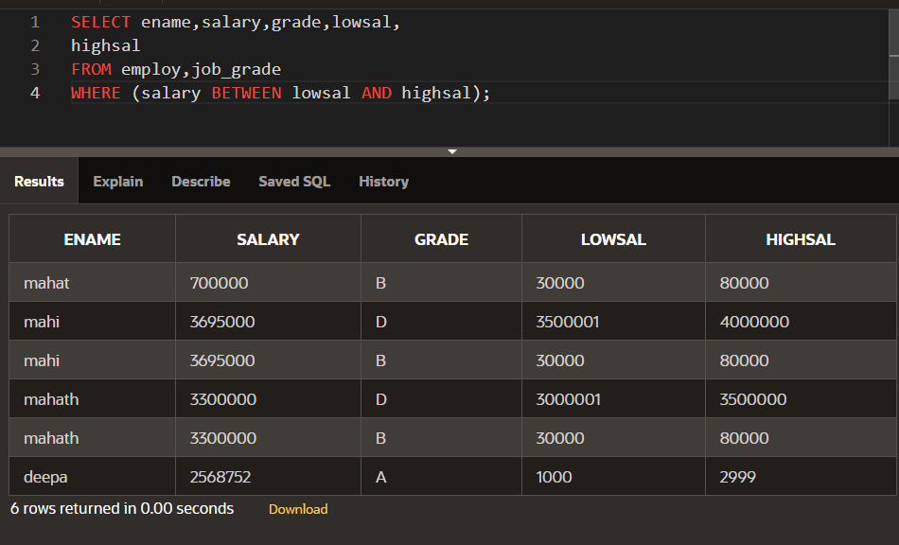

**Section 6**

**HEARIACHEY LEVEL**

select level id,name,deptid

from emp

start with id=100

connect by prior id=deptid;

**HIERACHIAL USING START WITH KEYWORD**

select id,name,deptid

from emp

start with id=100

connect by prior id=deptid;

**FULL OUTER JOIN**

select e.id,e.name,d.deptid,d.dept_name

from emp e full outer join dept d

on (e.deptid=d.deptid);

**RIGHT OUTER JOIN**

select e.id,e.name,d.deptid,d.dept_name

from emp e right outer join dept d

on (e.deptid=d.deptid);

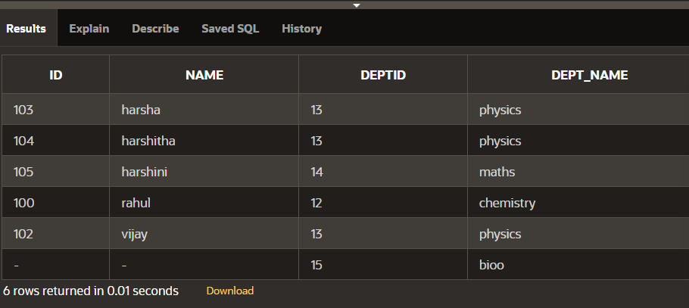

**LEFT OUTER JOIN**

select e.id,e.name,d.deptid,d.dept_name

from emp e left outer join dept d

on (e.deptid=d.deptid);

**ON CLAUSE**

select id,name,dept_name

from emp e join dept d

on(e.deptid=d.deptid);

**USING CLAUSE**

select id,name,deptid,dept_name

from emp join dept using (deptid);

**CROSS JOIN**

select id,name,dept_name

from emp cross join dept;

**NATURAL JOIN**

select id,name,deptid,dept_name

from emp natural join dept;

**Section 5**

**NVL FUNCTION**

select id,nvl(dept,'not assigned')

from singer;

**NVL DATE**

SELECT NVL(TO_CHAR(hiredate, 'YYYY-MM-DD'), 'no date')

FROM singer;

**CHARACTER TO DATE**

select to_date('may10,1989','fxmondd,yyyy') as "convert"

from dual;

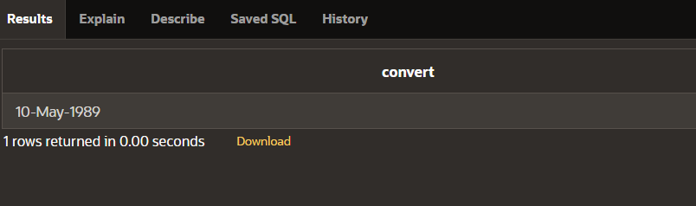

**NUMBER TO CHARACTER**

select to_char(salary,'$99,999')

from singer;

**DATE TO CHARACTER**

select to_char(hiredate,'month dd,yyyy')

from singer;

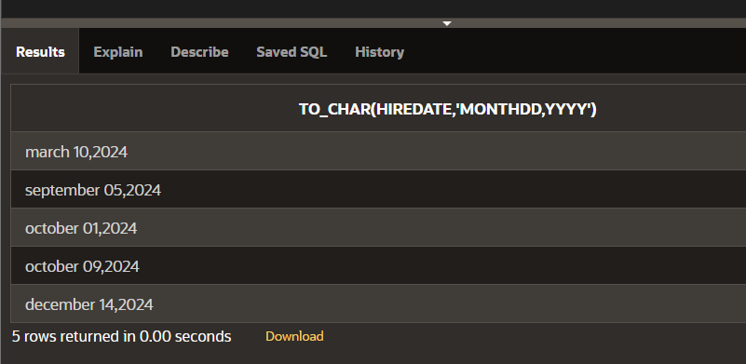

**DATE FUNCTION**

select id,name,hiredate,round(months_between(sysdate,hiredate)) as tenure, add_months(hiredate,6) as review, next_day(hiredate,'friday'),last_day(hiredate)

from singer;

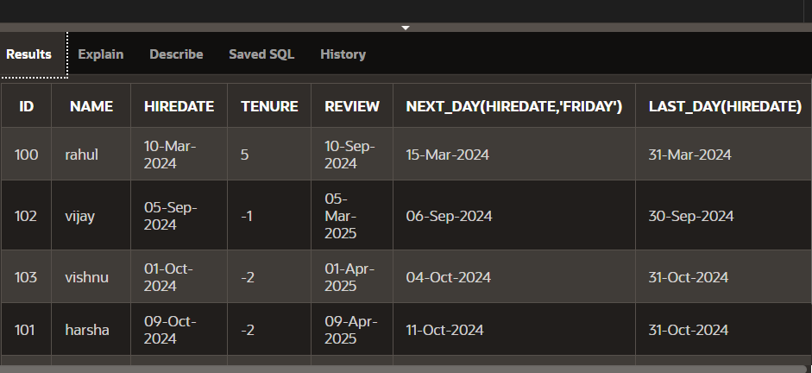

**Section 4**

**TRUNC**

select hiredate,

trunc(hiredate,'month')

from singer;

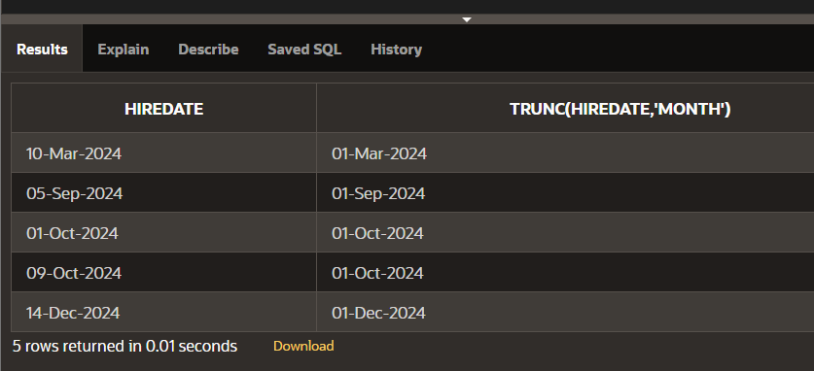

**ROUND TO HIREDATE**

select hiredate,

round(hiredate,'month')

from singer;

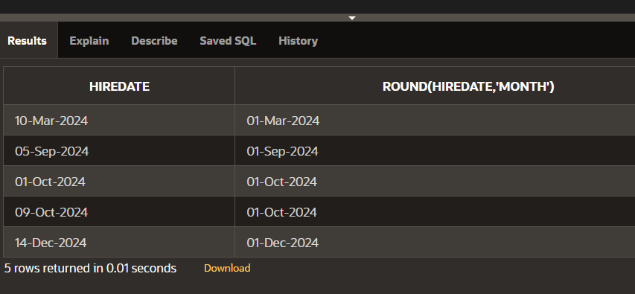

**LAST DAY**

select last_day(sysdate)

from dual;

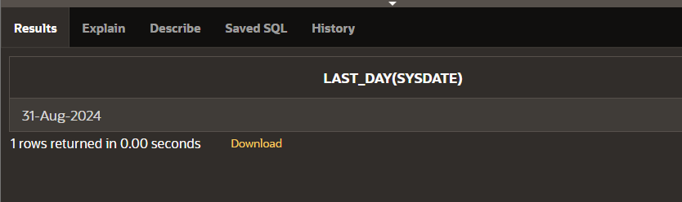

**NEXT DAY**

select next_day(sysdate,'monday')

from dual;

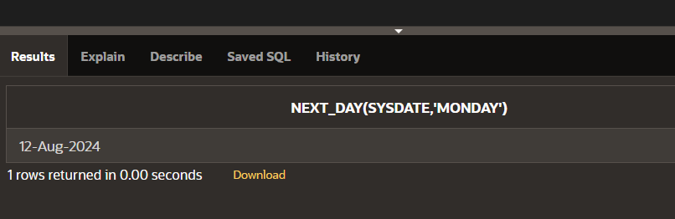

**ADD MONTHS**

select add_months(sysdate,5)

from dual;

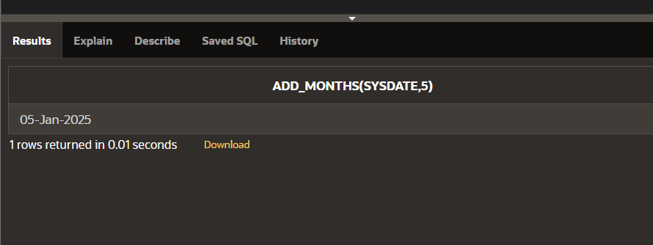

**MONTHS BETWEEN**

select id,name

from singer

where months_between

(sysdate,hiredate)<100;

